UMAP

Introduction
Hello everyone and welcome back to the final video of this dimensionality reduction series. So far we've had a look at PCA, MDS and TNE and now it's finally time to talk about one of the most recent methods which [music] is UMAP. According to some memes on Reddit, UMAP appears to be superior over TNE. But is this actually true? To answer this question, we should begin with discussing if there is at all anything that we would like to improve in Tesney.

Local vs. Global Technqiues
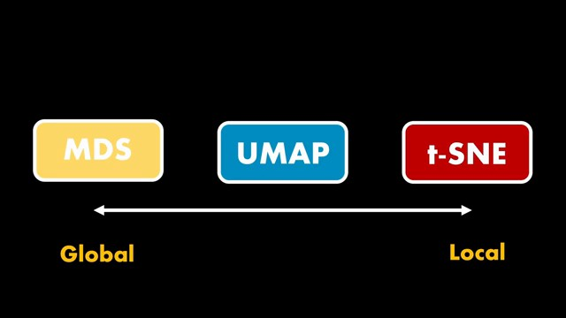
The techniques we discussed so far are somewhat located at the extremes when it comes to what kind of information is preserved. MDS, for example, is trying to preserve all global distances and we learned that this is not ideal because it's simply not possible in a **lowdimensional space. TES on the other** hand restricts itself to only look at the local neighborhoods and therefore might miss the overall structure in the data. That's also the reason why distances between clusters of Tesney points are meaningless. The main argument for this behavior is typically that the KL divergence loss used in Tesney doesn't care about the global structure. Now, UMAP claims to preserve both local and most of the global structure in the data. So, it sits somewhere in between. This comes from how the algorithm is designed by paying more attention to the overall geometry of the data. Well, but there's some discussion around it.

Is UMAP better?
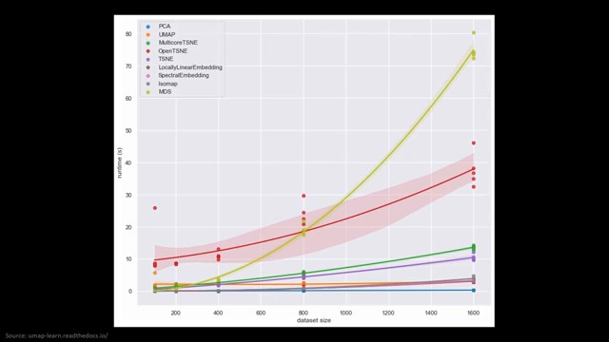
A paper by Kobach and Linderman has for example shown that these differences mainly arise from how the algorithms are initialized. So there is no evidence per se that UMAP has any advantage over TES in terms of preserving global structure. One clear advantage however is the computational complexity which is close to linear and therefore faster than the quadratic complexity of the traditional TNE. As this plot from the documentation shows, UMAP is clearly faster when the data set sizes become larger. And the comparison also includes approximations of TES like Barnes Huts which is indicated by the green line. Having cleared up these rumors, let's now talk about UMAP.

The Paper
UMAP stands for uniform manifold approximation and projection. The technique was published in 2018 by Leland Mckins, John Healey and James Mel which are researchers from the Canadian Tut Institute for Mathematics and Computing. A historical side note, William Tut was a British Canadian mathematician. Reading this paper was very refreshing as it is one of the most comprehensive papers that I've read in the last years.

Topological Data Analysis Primer
In order to understand UMAP, we will have to make a short journey into the world of topological data analysis. In the paper, there's a complete section on the theoretical motivations drawn from this field. And therefore, we will first build the foundations to understand the rest of the technique.
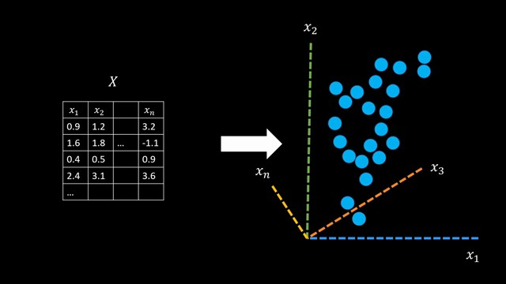
As you know, data usually corresponds to a set of points which are arranged in a highdimensional space also called the ambient space. Each feature corresponds to a new dimension. Now topological data analysis or short TDA is interested in the shape of the data in the space or in other words the manifold. In the TDA toolbox there are different methods that help us to extract topological and geometric features of the data. This mathematical field is also called homology. Such features can for example be connections, loops or holes in the data set and they can reveal interesting details about our data. So the set of points on the right doesn't give us any topological information per se. So how do these methods calculate topological features? All of this is based on triangles. As you might know, surfaces are often approximated using triangles and this is for example used in computer graphics in video games. Triangles are the simplest polygons and a nice property of triangles is that we can construct all other polygons with them which is called triangulation. What's even nicer, we can generalize triangles into higher dimensions.

Simplices
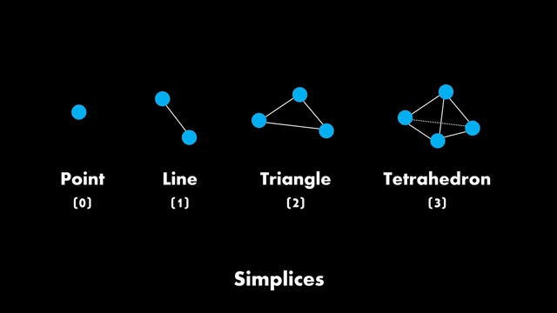
The triangle we just saw is a 2D example. For 3D, we call it a tetrahedron. These generalizations are also called simplices. One of the most basic ideas in topological data analysis is to simply clue simplices together along faces to approximate the geometry in the data.
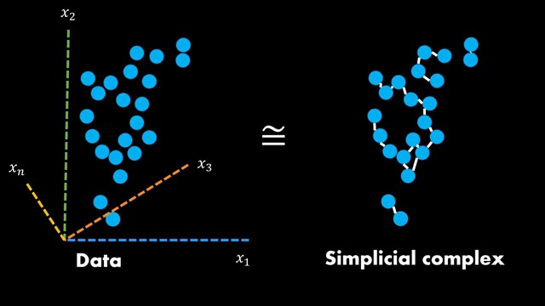
The result of that is a so-called simplicitial complex which we can see on the right. Don't take this sketch too seriously however because it's just based on zero and one simplices. The takeaway is that we can resemble the topological structure in our data by cluing together simplices. Later we will see that a similar approach is used in UMAP to learn the local structure of the manifolds. for TDA. We can now calculate all of our geometric features on this graph directly, which is quite convenient. So far so good. The last question is how do we actually build such a simplicial complex? So how do we glue these things together?

Filtration
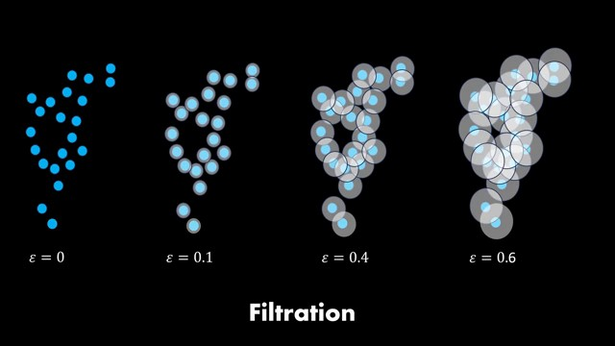
The general approach used in TDA is called filtration. We simply put balls of a fixed radius epsilon around each point. And whenever these balls overlap in certain ways, we connect the points. This automatically generates a graph for each radius epsilon.
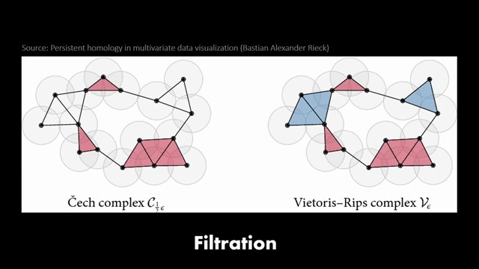
In simplicial homology, all of this is defined much more concretely. And in fact, there are different ways to build these structures. For UMAP, we mainly care about the Vtorius RIPS complex, which is determined by the zero and one simplex. A great Python library called Gioto TDDA has a nice visualization of the filtration procedure. As you can see, with each new radius epsilon, the shape is evolving and we get a pretty good feeling for how the shape of the data looks like, which is of course also true for higher dimensions. For UMAP, this little introduction is probably sufficient at this point, but I will talk about one more detail because I simply find it important. Given this evolving structure, we now have different levels of topological features. There's a large hole in the data set at some point which gets destroyed again once the radi become too large. So what level of granularity is the right one?

Persistent Homology
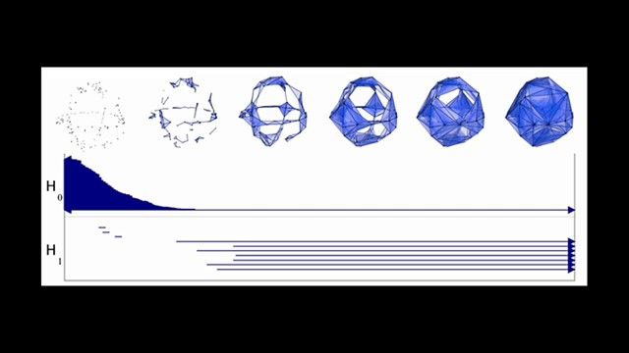
To make this even more concrete, if we perform filtration on such a shape, we will get information about many small holes but also a big hole. So how do we know which hole is the feature we are interested in? This is where persistent homology comes into play. It simply tracks the beginning and end of these features throughout the filtration procedure. That's also where the name comes from. It checks which topological features are persistent over the radi. Thinking about um again, topological theory provides guarantees about how the manifold of the data can be captured in a meaningful way. And that's why we started this video with this quick primer.

UMAP Overview
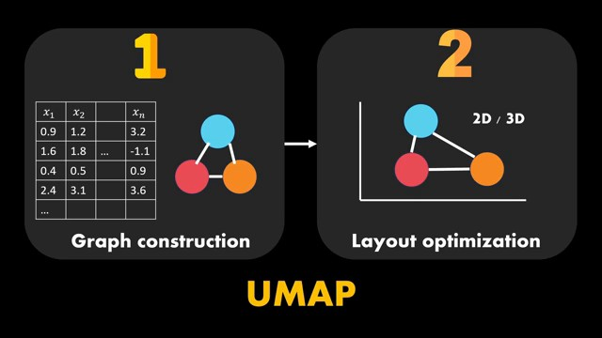
We can now discuss the um algorithm in two steps. First we construct a topological representation using the vtorus fris complex which effectively gives us the k nearest neighbor graph. Secondly we find a lowdimensional representation that has a similar topological structure and this in the end is a graph layout optimization in the ukidian 2D or 3D space. The actual implementation is quite simple, but the authors emphasize that the mathematical framework serves as a foundation to justify the approach.

Step 1: Graph construction
Let's discuss the first step in more detail. In the TDA introduction, we learned about the Vtorius RIPS complex and how it can be built using filtration by putting a radius around each point. We will do something similar in UMAP. An immediate question now is which radius should we pick to construct a simplicial complex that approximates the manifold on which the data lies. There is no one sizefits-all radius for all data sets and therefore UMAP has a hyperparameter which is the number of neighbors. In order to understand why it's not a radius anymore, we will have to dig a little deeper. All of this has to do with the U in your map which stands for uniform. Let's assume our data lies on this manifold.

Uniform distribution
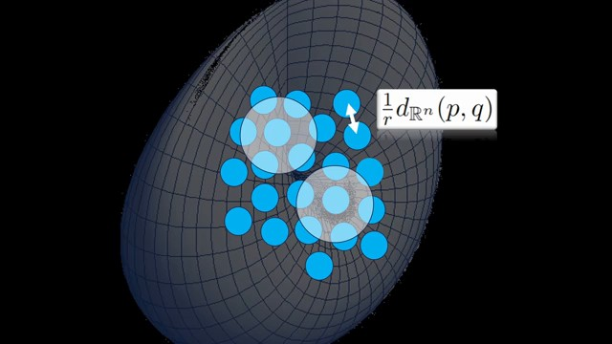
If the data is uniformly distributed on a manifold, a consequence is that we always roughly capture the same number of neighbors if we position a ball with a radius somewhere. In this example, we have six neighbors for a given radius. This would make it quite easy for us as we could always choose the same radius epsilon and capture the topology at the right resolution for the entire manifold. There's even a theorem, the nerf theorem, which proves this observation from a mathematical point of view. If the data is uniformly distributed on the manifolds, a simplicial complex of the cover of the data will approximate the manifold correctly. All of what we've just seen is also formulated mathematically in the paper in lema 1. Given a remmanion manifolds in an ambient space and given a bunch of locally constant points P, we can approximate the geodessic distance using balls centered at each point. This means if the data is uniformly distributed like in this example, the geodessic distance on the manifold is simply one divided by the radius of these balls which is simply the average distance between points.

Non-uniform real-world data
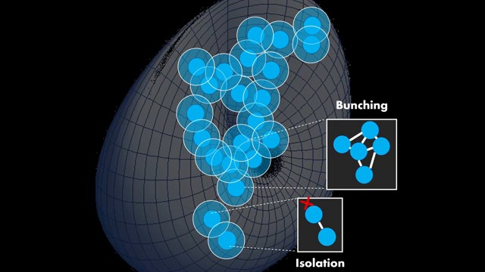
The only problem is that real world data doesn't behave that nicely. The data might be scattered around like this. If we place a ball with the same radius on this collection of points, we might get a different number of neighbors for each of the points. And one first issue we observe is that the two points on the bottom are isolated from the rest of the points. In the end, we however want to have one global simplicial complex that covers all of the data. The problem here is that the previously mentioned nerf theorem doesn't apply anymore because the data doesn't cover the manifold sufficiently. Another problem is that at some places the balls cover too much which results in very highdimensional simplices. That's also not ideal because it simply doesn't reflect the global manifold structure in that area. All of this would be much nicer if the data was uniformly distributed. But what can we do about it? UMAP is called uniform manifold approximation for a reason. So there must be a way to introduce uniformity. And that's exactly what the authors do.

Enforcing uniformity
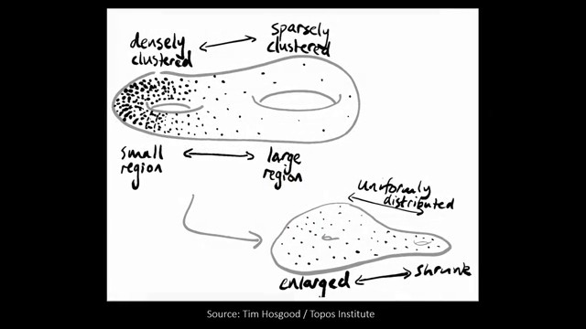
Looking at lema one once again, the authors simply decide to give each point an individual distance function such that the data is approximately uniformly distributed with regard to that metric. This way the assumption of uniform distribution still holds and we are able to approximate the geodessic distance according to this lema. I found this sketch by Tom Hosgood which nicely visualizes the effect of these individual distance functions to force the data to be uniform. The geometry changes. Sparsely clustered regions will shrink and densely clustered ones will be enlarged.
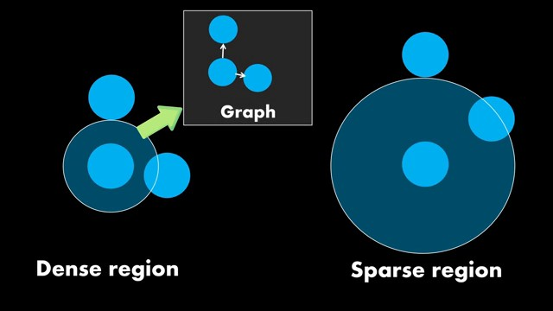
Practically this means that the balls around each point stretch to the k nearest neighbor of the point. Choosing k equals 2, it could look like this. In dense and sparse regions, instead of choosing the radius, we now simply choose a value for the number of neighbors. This is more convenient because choosing actual distances is very data set dependent. Whereas the default value, for example, 10 neighbors works quite well for most of the data sets. If we would build a simplicial complex out of this information, it would result in a simple graph that looks like this.

Exponential decay
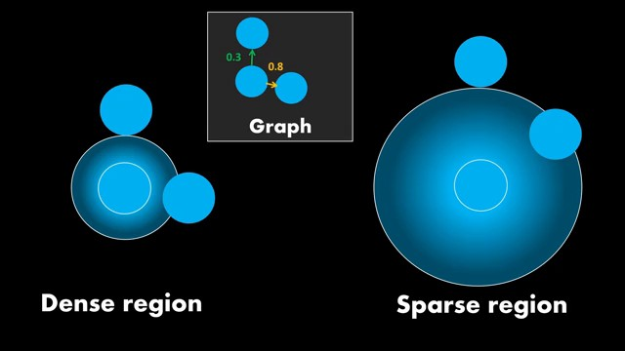
With our local metric, we can now also measure distance between the points. And therefore, we can also include information about how close the neighbors are. This means our radius can be interpreted as the probability that a connection exists. In practice, an exponential decay is used around each point to give more weight to points that are closer in the neighborhood. This information can also be used in our graph, namely by putting weights on the edges. Here, the first neighbor receives a higher weight because it's closer to our center points. Unfortunately, using this approach, it can still happen that points become isolated because they are too far away simply because the exponential decay assigns a very small value to them.

Local connectivity constraint
The authors decide to add a local connectivity constraint such that the decay starts beyond the first neighbor. This eventually looks more or less like this. As you can see, we have no exponential decay until the first neighbor and then the exponential decay starts beyond the first neighbor in our graph. This leads to a connection weight of one for the first neighbor and then to smaller weights for all other nearest neighbors except for having no isolated points. This also has further beneficial implications.
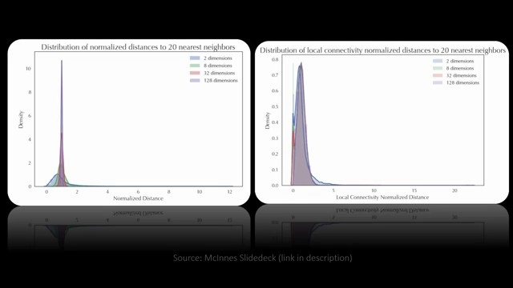
As distances in the highdimensional space tend to be larger to the first neighbor, the distance distributions are typically cramped together. We've also seen this in the previous videos of the series. As you can see, when introducing the local connectivity constraint, the distributions become a bit wider because it stretches out to the first neighbor. This result can also be demonstrated mathematically and shows that UMAP is not simply building a K nearest neighbor graph, but many considerations went into the design of the method. In the documentation for the UMAP Python library, there's also a nice visualization of the whole graph construction. As you can see, the circles around each point stretch to the first neighbor and then start to decay exponentially.

Distance function
All we've just seen is mathematically expressed in the paper using the following distance function.
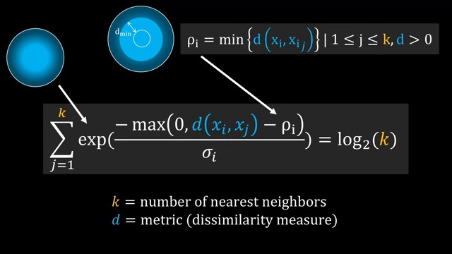
This formula eventually defines how large the radi around each individual point are. And as we know by now, this is controlled by the number of nearest neighbors K. Let's begin with the term on the left. Here we find the exponential decay around the center point that weighs the neighbors according to their distance. In the exponent we find this complex looking term which is nothing else but the local connectivity constraint we just discussed visually. By subtracting row I which is defined as the minimum distance among the nearest neighbors. We make sure that the exponential decay starts only beyond the first neighbor. That's because subtracting the first neighbor's distance leads to negative values which are replaced by zero because of the maximum operator and anything to the power of zero is one. So we will always have a connection probability of one. It's also possible to visualize this distance function which you can see here. Finally, sigma i is a normalization factor that allows to control the intensity of the decay. If we now sum over the decayed distances to all nearest neighbors, we roughly want the ball to capture the probability mass of log 2 of K. There's not much information in the paper why lo 2 is used, but I read on GitHub that empirically this leads to better results. K simply acts as a global constant that defines how locally we want to estimate the metric. If we set it to a higher value, we will have larger balls around each point and capture more of the global structure. At this point, one or the other might spot some similarities with TNE. I will talk more about this later in this video.

Local metric spaces
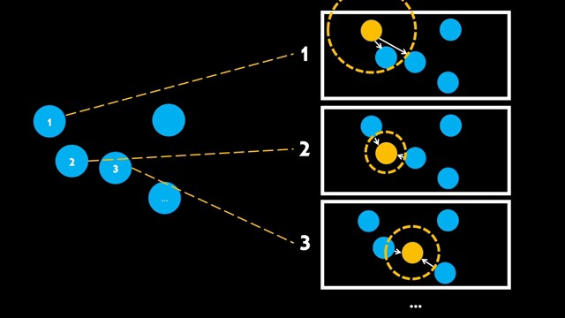
So given this new distance function, we now have a local view for each individual point in the data set. For a specific number of nearest neighbors, such as two here, we get a radius around each point that connects the point to all neighbors within the radius. This gives us a graph for each data point, more specifically a weighted graph as we can also put the connection probability on the edges to indicate which points are closer than others. Note that the edge weights between nodes are not a symmetric relationship. One node might be a nearest neighbor over another nodes but not vice versa.

Fuzzy simplicial complex
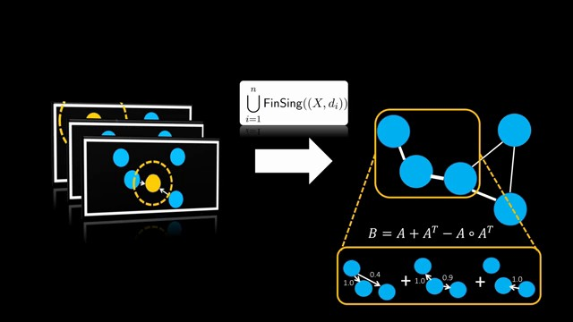
The real challenge now is to combine all of these individual weighted graphs into one large simplicial complex that represents the entire manifolds. How would you come up with for example this subgraph given the individual weighted nearest neighbor graphs? Do we take the max of the edge weights or the average or what do we do? Mathematically speaking, we have different local metric spaces for each data points and want to merge them into a join simplicial complex. The math section of the paper tells us exactly how this can be done. Namely, by converting the graphs to fuzzy simplicial sets. In fuzzy simple sets, the membership is not binary, but instead a probability between zero and one. And that's exactly the situation we have with our edge weights. And in fuzzy topology, there exists already a clearly defined operation for merging representations, which can be found in definition 9 in the paper. The basic idea behind it is that the combined edge weight is the probability that an edge exists minus the probability that no edge exists. This combined weights then represents the probability that at least one of the edges exist. In this formula, a corresponds to the adjacency matrix of the graph. We won't get too deep into the math here, but if you want to read more about it, I've added a more mathematical slide deck to the video description. Following this merging approach, we have a mathematical guarantee that we obtain an appropriate topological representation of the whole data set.

The full picture of step 1
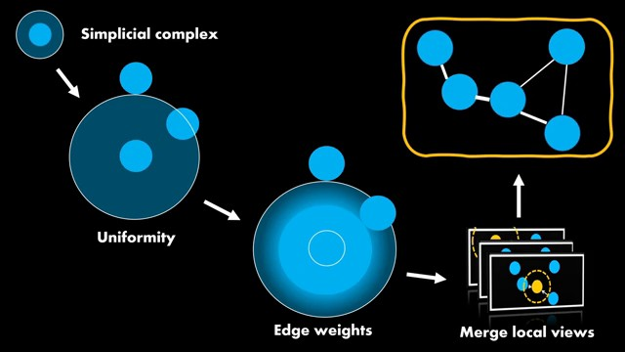
Now the full picture, we started with drawing balls around each point to build the simplicial complex. Then we made these balls stretch to the kith nearest neighbor to ensure local uniformity over the manifolds. Then we added exponential decay beyond the first neighbor to have edge weights that correspond to the distance. Finally, we found a mathematically grounded way to merge all of the local views of the topology. And eventually, we have a weighted K nearest neighbor graph that represents the structure in our data set.

Step 2: Graph layout optimization
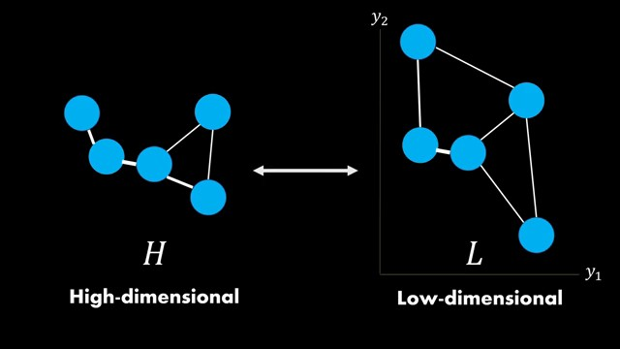
So now, let's talk about the second step, which is how do we produce a lowdimensional embedding that preserves exactly this structure. We start with our highdimensional weighted nearest neighbor graph. Let's call it H. For the lowdimensional 2D or 3D space, we initialize the points somehow. Later, we will also discuss different ways to do this, but let's focus on more important things first. For this set of points, we apply the same procedure as in the highdimensional space, which gives us another k nearest neighbor graph with weighted edges, which we call L. Now we want to change this lowdimensional graph such that it approximates the highdimensional one as good as possible. For this we need to compare the two graphs somehow.

Comparing graphs
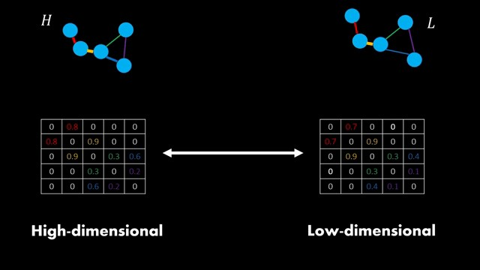
I don't know if you ever try to compare graphs but it's a challenging problem. Here we luckily have a onetoone correspondence for the nodes because we can simply say this highdimensional point belongs to this low dimensional point. As a result, the only thing we actually need to compare are the edges or more specifically the edge weights. When taking a look at the UMAP Python implementation, we can see that the comparison between these graphs is nothing else but the comparison of their adjacency matrices. These are the adjacency matrices of our two graphs and the entries can be simply interpreted as edge probabilities. I highlighted the edges in different colors to show that the graphs can have a different number of edges and therefore it doesn't suffice to only compare the existing ones but also the non-existing edges. In other words, the adjacency matrix will consider everything at the same time and therefore is the only reasonable choice here. By moving the lower dimensional adjacy matrix closer to the highdimensional one, we end up with a graph that approximates the original graph H. Okay, so how do we actually compare the two adjacy matrices? Do we subtract them from each other or what is the right way? The edges are simply Bernoli variables and therefore it makes sense to use the cross entropy over all existing edges.

Cross entropy loss
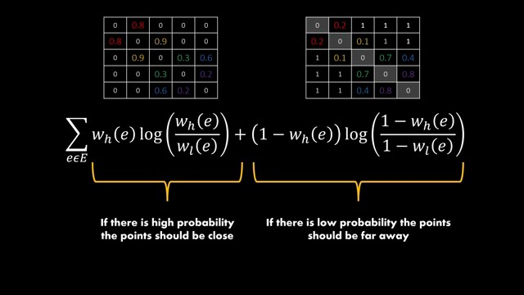
Let's inspect this formula closer. Cross entropy simply compares the edge probabilities for the high and lowdimensional graph for both cases when edges exist and when edges don't exist. On the left are all of the existing edges and on the right the adjacency matrix shows one minus the edges which gives values for the non-existing edges. The first term then simply makes sure that the lowdimensional points are close to each other when they have a high edge probability. And the second term makes sure that the points with low probabilities will be far away in the embedding space. Using this loss function, we can simultaneously optimize the position of all points. You probably already guessed it. We can adjust the coordinates of the lowdimensional points using stoastic gradient descent using this loss function.

Attractive and repulsive forces
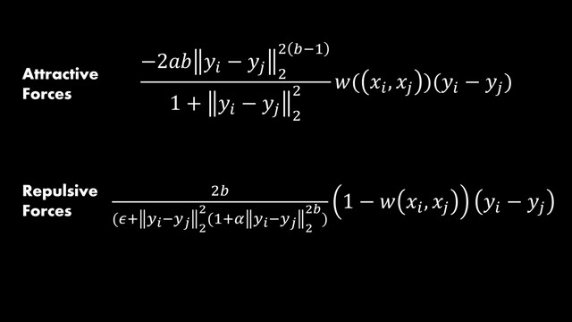
The authors mentioned that using this loss function corresponds to a force directed graph layout algorithm. This simply means that the points push and pull each other until a steady state is reached. We've also seen this in the Tes video. In case you're interested, it is even possible to derive the exact attractive and repulsive forces given this optimization function. Y I and YJ correspond to the coordinates of two lowdimensional points. For edges between these points with higher weights, the attractive forces are stronger whereas lower weighted edges have stronger repulsive forces. You can find more details about this in the UMAP paper.

More details
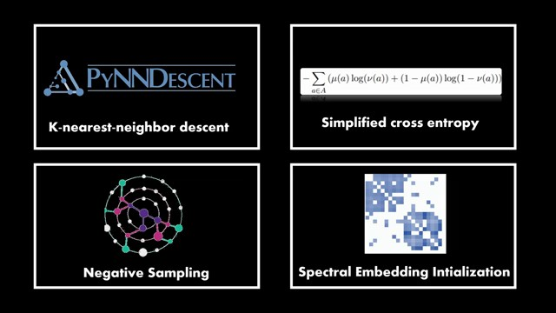
So those were the most important aspects of UMAP. And before we do a little bit of hands-on coding, let me quickly talk about four more minor things that are used in the actual implementation. We haven't talked about how the K nearest neighbors are actually found. As this needs to be done many times and therefore should be fast, the efficient K nearest neighbor descent algorithm is used. It has an empirical complexity that is close to linear. It's an approximation by only looking at neighbors of neighbors instead of the full data set. Next, the actual loss function is slightly simplified as some of the terms can be removed. Additionally, negative sampling is used to not deal with all negative edges in the adjacency matrix. This speeds up the optimization. Finally, the initialization of the lowdimensional points is not random, but the authors use a technique called spectral embedding. I won't go into the details here, but you can simply think of it as a technique designed for graphs or more specifically their adjacency matrix. And this leads to a better starting position for the lowdimensional points.

t-SNE vs. UMAP

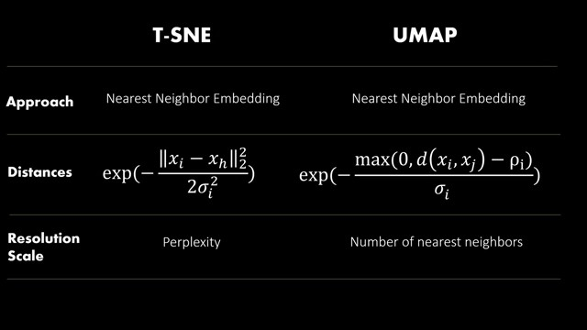

The Table to remember
